HealthFlex Annual Election 11/3-18/21

It is that time of year again! Our HealthFlex Annual Election period for Clergy and Lay eligible members is November 3rd through 18th, 2021. This is your opportunity to enroll or waive coverage for yourself; add or remove an eligible child or spouse; waive coverage for eligible dependents on your HealthFlex plan or change your plan altogether! Elections you make during this period will take effect January 1, 2022.

Unless you have previously waived coverage, you will need to access your record through Wespath and renew your selection. Please note: If you do not make an election, your HSA contributions revert to zero.

ALEX Benefits Counselor is now LIVE and updated for 2022. You can use this tool to estimate costs and receive a personalized recommendation for your 2022 HealthFlex Elections. ALEX will remain available throughout the Annual Election period (November 3-18) and participants can visit as often as they would like. Remember, ALEX does not make or save elections. You will still need to go to Benefits Access and make your elections.

To get to ALEX directly, click HERE.

.
We are offering a virtual Annual Election meeting on October 27, 2021 at 2 pm EST. CLICK HERE to register for this event

Follow the links to access the "2022 HealthFlex Plan Comparisons"
- Spanish
- Korean
- English
Follow the links to access "How Do I Choose My HealthFlex Plans?"
- Spanish
- Korean
- English

Below are the rate tables for 2022.
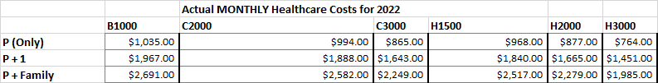
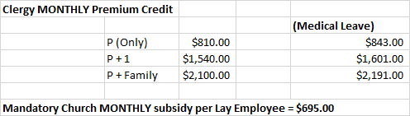
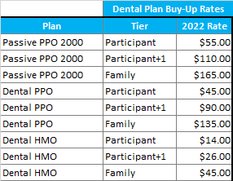

 | Vision Plan Buy-Up Rates
Plan | Tier | 2022 Rate
Premier | Participant | $14.16
Premier | Participant+1 | $22.94
Premier | Family | $36.38
Full Service | Participant | $7.96
Full Service | Participant+1 | $12.86
Full Service | Family | $20.34
Core | Participant | $0.00
Core | Participant+1 | $0.00
Core | Family | $0.00

