
E EASTERN PA UNITED WOMEN IN FAITH’S 53rd Annual Celebration

Gun Sense in Our Communities

Memorial to the Lost Vigil
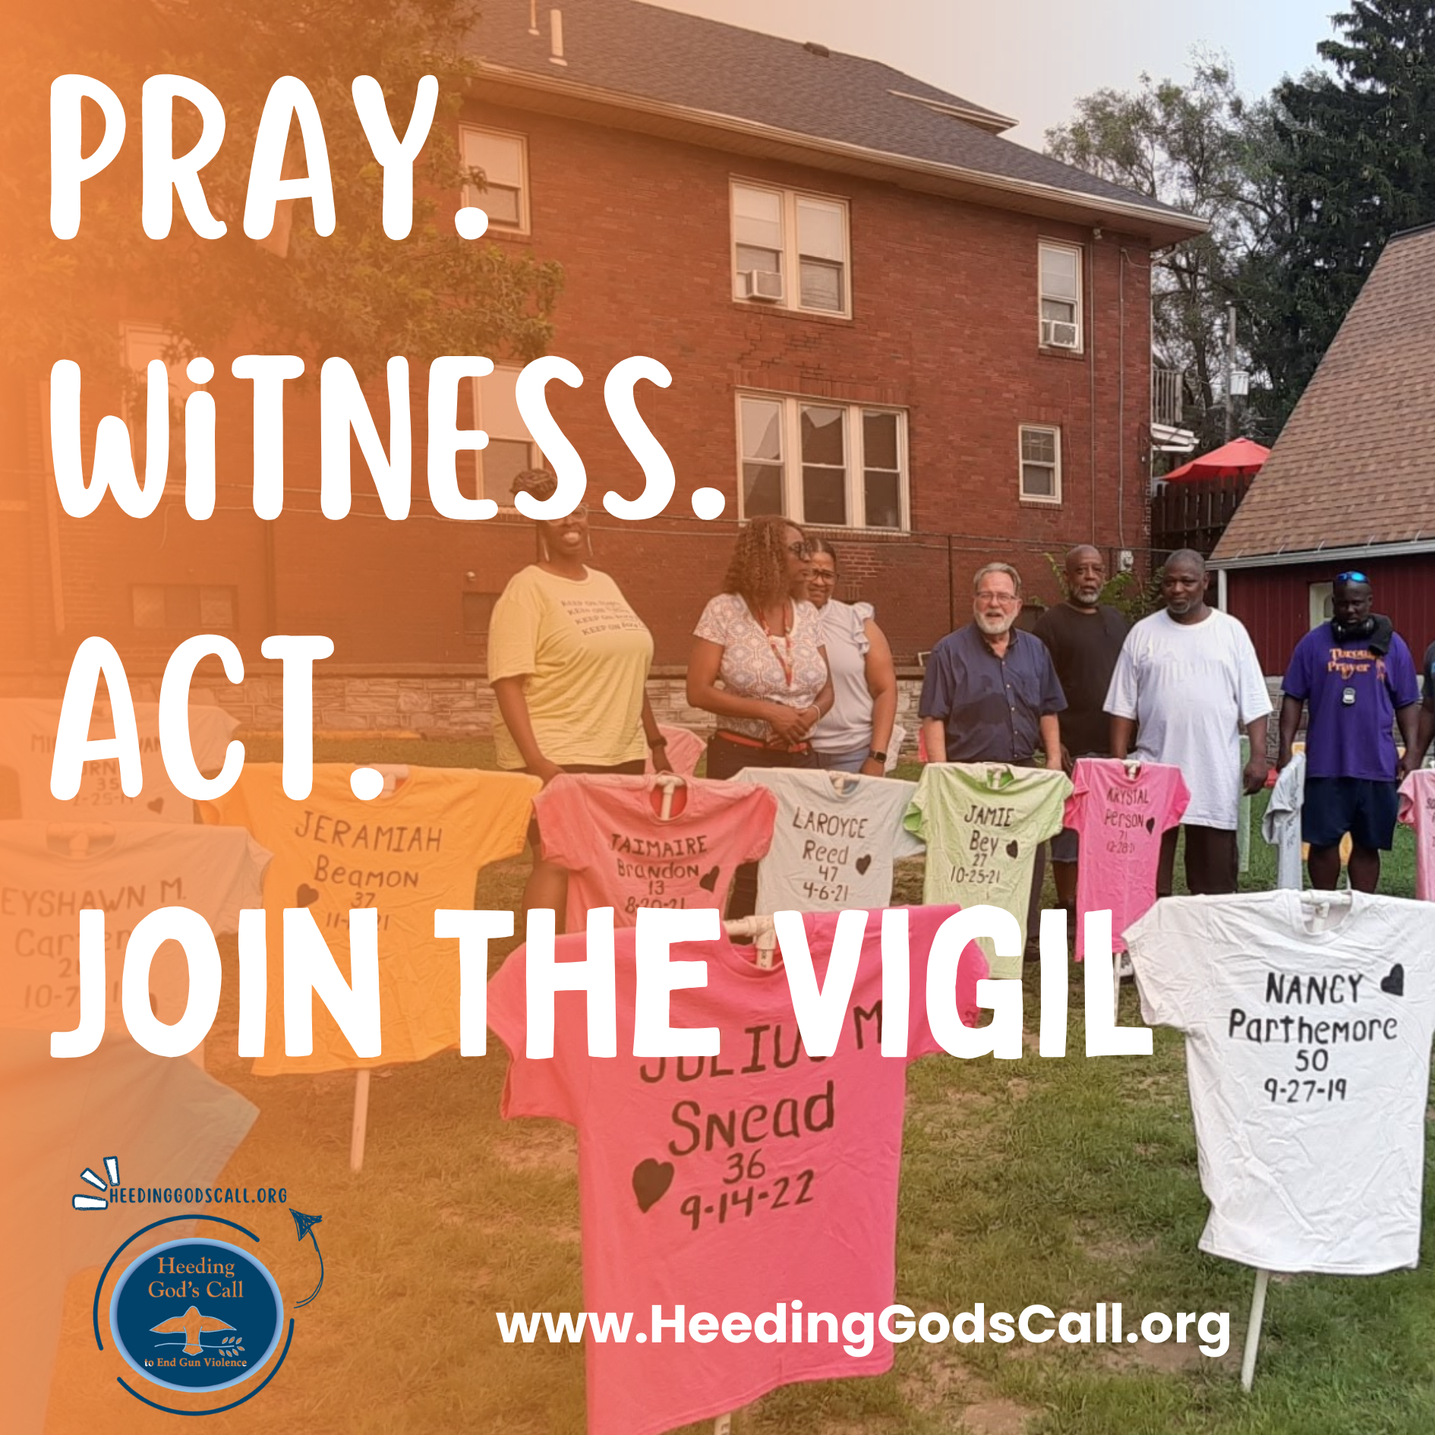

Sat. October 24

Scottsville United Methodist Church
2400 Brownsville Rd.
Feasterville/Trevose, PA 19053

9:00a- 2:00p

Cost- $20 (check or cash) includes Lunch

>>>>>>>>>>> REGISTRATION DEADLINE OCTOBER 14 <<<<<<<<<<

By email- Send name, phone # and sandwich choice to Lillian Mannon,
lillianmannon@gmail.com. Pay at the door (cash or check).

By US Mail- Send name & phone # with Registration tear off below AND check to
Lillian Mannon,
958 Jeffrey Lane, Langhorne, PA 19047
Checks payable to EPA United Women in Faith

See Page 2 for Registration Tear-Off & Schedule Details!

REGISTRATION

NAME: ______________________________________________________________
UNIT/CHURCH: _______________________________________________________________
ADDRESS:______________________________________________________________________________ __________________________________________________________________________________________
PHONE:______________________________ EMAIL:_______________________________________
Check: $______________
Lunch: Assorted hoagies from Wawa, fruit cup, Tastykakes,
Chips, and drink
Cost $20.00 - Please indicate choice of meal
____Italian ____Turkey ____Roast Beef ____Ham ____Veggie

If you have a special food need, please indicate this on your registration.
If registering for more than one person from your unit, please indicate names and choice of meal on the back of your registration form.
>>>>>>>>>>>>>>>>>>>>>>>>>>>>>>>>>>>>>TEAR OFF HERE>>>>>>>>>>>>>>>>>>>>>>>>>>>>>>>>>>>>>

Wear casual clothes, we will be outdoors from 9:45- 10:15am
SCHEDULE OF EVENTS
9:00- Registration / Hospitality in Fellowship Hall
9:45promptly- Memorial to the Lost Vigil (outdoors- RAIN or SHINE)
9:00-10:45- Gun Sense Resource Fair in Fellowship Hall
11:00-UWFaith Gathering in Sanctuary
12:00- Lunch
1:00- UWFaith Gathering in Sanctuary

Questions?? call Rhonda Rea 215-493-9505

