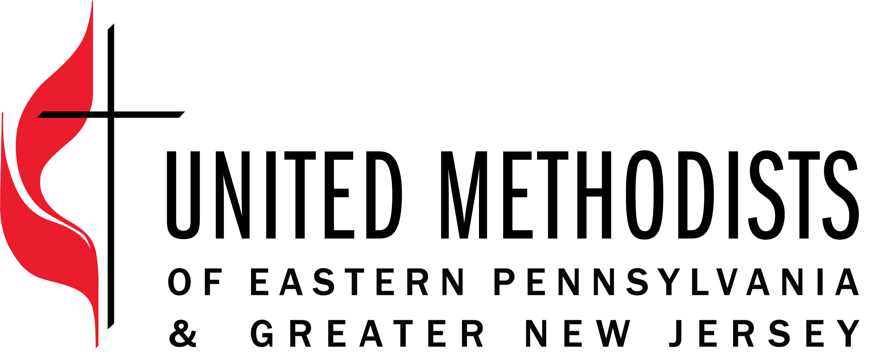

The United Methodist Church forms disciples of Jesus Christ who, empowered by the Holy Spirit, love boldly, serve joyfully, and lead courageously in local communities and worldwide connections.

Title: Creative Media Specialist
Classification: Non-Exempt, Part-Time (20 hours/week)
Hourly Rate: $25
Band Description: Specialist
Supervisor: Executive Director of Communications

Position Summary
The Creative Media Specialist develops and disseminates inspiring and engaging social media and written content for United Methodists of EPA and GNJ, supporting our mission to recruit and equip transformational spiritual leaders to make disciples and grow vital congregations to transform the world. This is a part-time position within the communications team.

Essential Functions
- Compile creative and engaging content for social media including the Facebook and Instagram accounts for EPA, GNJ, & IGNITE
- Maintain EPA&GNJ social media content calendar.
  - Plan posts to ensure that social media content is current, reflecting the season in the life of the church, special days on the calendar
  - Manage, curate, and track social media posts
- Balance and weigh written and visual content to reflect diversity, intercultural competency, and theological differences within our conferences.
- Write 3 editorial features a month that highlight local church ministries and conference initiatives.

Organizational Responsibilities
- Related communications duties such as photography and representing communications team on project teams.
- Assist in EPA & GNJ meetings and events

Core Competencies
- Committed to continuously grow in intercultural competence
- Build and maintain relationships that are rooted in honesty, integrity and honoring confidentiality
- Work collaboratively with others to produce innovative solutions
- Meet deadlines
- Ability to convert ideas into stories, linking EPA&GNJ’s mission to action

Qualifications
- Portfolio of written and visual materials that demonstrate proficiency in content creation
- Excellent writing and editing skills in English
- Evidence of collaboration with clients and within an office environment
- Hands-on experience with MailChimp, WordPress, SEO tools, Microsoft Suite, and social media

Education
- Bachelor’s degree in journalism, communications, or public relations preferred

Travel
The position requires some evening and weekend responsibilities and some travel beyond the office. The position works in a hybrid model from the EPA office in Norristown, PA.

Employee Name:

Employee Signature: ___________________________________________________

Date: _________________________________

Supervisor Name:

Supervisor Signature: ___________________________________________________

Date: _________________________________

