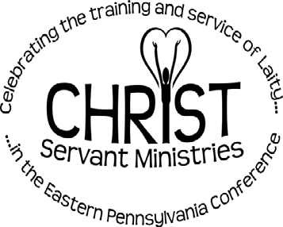
Annual Report - Request for Continuation
Christ Servant Ministries
Eastern Pennsylvania Conference of the United Methodist Church

Use this report...
- To fulfill the 2016 Disciplinary Requirement that each participant in the Christ Servant Ministries program
-- whether Christ Servant Minister, Certified Lay Speaker, or Certified Lay Minister -- complete and submit an annual report to his or her charge conference to remain in good standing.
- To provide information to the Conference Director for inclusion in the Conference Journal and on the CSM website, “www.ChristServantMinistries.net”.

Part 1. Information about the Lay Servant
☐ Mr. ☐ Mrs. ☐ Ms. Name: Click or tap here to enter text.
What name do you go by? (i.e. Sue, Bob, Jim) Click or tap here to enter text.
Address: Click or tap here to enter text.
City/State/Zip: Click or tap here to enter text.
Home Phone: Click or tap here to enter text. Work Phone: Click or tap here to enter text.
E-mail: Click or tap here to enter text.
Name of District: Click or tap here to enter text.
Name of Church: Click or tap here to enter text.
Church Address: Click or tap here to enter text.
City/State/Zip: Click or tap here to enter text.
Church Phone: Click or tap here to enter text. Church E-mail : Click or tap here to enter text.

Part 2. Lay Servant’s Request to continue the journey
I want to continue my journey as a Lay Servant: ☐ Yes ☐ No

Part 3. Status of the Lay Servant
☐Christ Servant Minister ☐ Certified Lay Speaker ☐ Certified Lay Minister List the DATE(s) and TITLE(s) of advanced course work taken since your last annual report
Click or tap here to enter text.

Part 4. Servant’s Request
I request recommendation of my pastor and my charge conference to begin or renew as a…
☐Christ Servant Minister ☐ Certified Lay Speaker ☐Certified Lay Minister

Click or tap here to enter text. Click or tap here to enter text.
Date Signature of the Lay Servant

Part 5. Recommendation of the Pastor
As pastor, I recommend concurrence with the request of this person to begin or renew as
☒Christ Servant Minister ☐ Certified Lay Speaker ☐Certified Lay Minister

Click or tap here to enter text. Click or tap here to enter text.
Date Signature of the pastor

Part 6. Recommendation of Charge Conference (or) Church Council (for initial applications)
The charge conference of the Click or tap here to enter text. (church or charge) recommends approval of this request.

Click or tap here to enter text. Click or tap here to enter text.
___________________________ ____________________________________
Date Signature of the District Superintendent (or designee)

NOTICE: After the Lay Servant completes this form and signatures are obtained for Parts 4, 5, and 6, reproduce copies and distribute to: District Superintendent, Church Conference Secretary, and keep a copy for yourself. Also, mail copies of the form to the CSM District and Conference Directors. For any questions, please go to the website: www.ChristServantMinistries.net or call George Hollich: 717-838-2812

Part 7. Church Ministries
During the past year, I have participated in these ministry opportunities (please check the appropriate boxes, and then provide specific corresponding ministry opportunities):
☐ at my local church: Click or tap here to enter text.
☐ beyond my local church:
☐ in my district: Click or tap here to enter text.
☐ in my conference: Click or tap here to enter text.
☐ in my jurisdiction: Click or tap here to enter text.
☐ at the general church level: Click or tap here to enter text.
☐served as CHAIR of committee, board, task force: Click or tap here to enter text.
☐served as a volunteer at a community agency: Click or tap here to enter text.
☐provided one-on-one caring:
☐ at a hospital, nursing home, or to a shut-in
☐ in membership/evangelism visitation
☐other: Click or tap here to enter text.
☐provided leadership in caring/outreach projects such as a soup kitchen, prison ministry, etc. Please list: Click or tap here to enter text.
☐taught classes (what, how many): Click or tap here to enter text.
☐served as a worship leader in services (how many): Click or tap here to enter text.

☐delivered a devotional message (how many): Click or tap here to enter text.

☐preached in worship services (where, how many): Click or tap here to enter text.

Additional opportunities for leading, caring, and communicating ministries participated in by the Christ Servant Minister (describe opportunity and your part in it): Click or tap here to enter text.

Part 8. Personal and Spiritual Growth
Describe activities in which you have engaged and/or books you have read and used during the past year to help you develop your devotional life, improve your understanding of the Bible, improve your understanding of The United Methodist Church, or to improve your skills in leading, caring, and communicating?
I feel I have been gifted in the areas of
Click or tap here to enter text.

Part 9. Commentary about the Past Year
Do you believe that you have had adequate opportunity or service as a Lay Servant this year?
☐Yes ☐No If no, please explain:
Click or tap here to enter text.

What additional training or support do you need?
Click or tap here to enter text.

Give any recommendations you have for improving the Christ Servant Ministry program in your district or annual conference:
Click or tap here to enter text.

Part 10. Sharing of Information
I give my permission for information on this form to be shared…
in the Conference Journal: ☐Yes ☐ No on the Web site: ☐Yes ☐No
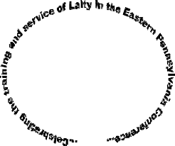
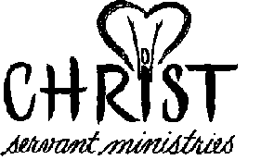
The Annual Report form is used to help the Charge Conference better understand the ministry and contributions of a Christ Servant Minister, Certified Lay Speaker, or Certified Lay Minister to the life of the congregation. This form has been approved for use by all the Districts of the Eastern Pennsylvania Conference.

INSTRUCTIONS FOR USING THE FORM
- If you are seeking renewal as a Christ Servant Minister, Certified Lay Speaker, or Certified Lay Minister please complete both sides of this form.
- The form is considered to be complete when it has been signed and dated by you the pastor, and the district superintendent (or designee). The original form is to be retained by the Recording Secretary of the Charge Conference and filed with the Charge Conference records. Additional copies are to be made and given to you, the Pastor, and the District Superintendent at the time of the Charge Conference.

Within one week following your Charge Conference, you need to send copies of your report to …
  - George Hollich, the Conference Director of Christ Servant Ministry,
  - Judy Ehninger (if you are a Certified Lay Minister),
  - and to your District Representative as listed below…

CSM Conference Director George Hollich, CSM 212 West Orchard Drive Palmyra, PA 17078
717-838-2812
Judy Ehninger, CLM 2620 Gracie Lone
Macungie, PA 18062
610-965-2290
South
Sheri Kentner, CLM
110 Beechwood Terrace
Pottstown, PA 19335 sherikentner@gmail.com
North
East
Ruth Portzline, CLM 216 Eagle Court
Jamison, PA 18929
215-343-4749
West
Lynn McCord, CSM 29 Pinewood Ave
Lititz, PA 17543
717-615-5616

last revised 9/01/2018

