Ezra Statistics Module Church User’s Guide
A module of the Ezra Data Management System

Table of Contents
Stats Home 2
Logging In 2
Welcome Panel 3
Side Menu Bar 4
Reports 5
Reports Menu 5
Individual Church Reports 5
Church Reports 6
Charts 7
Enter Stats 8
Submit Stats 11

Church Statistics Module

Stats Home
Ezra’s Statistics module is designed to allow churches to submit their year-end statistics to the conference digitally.

Logging In
First Log In (*If you have already logged in you can skip to the next section)
You can access the program by going to http://ezra.gcfa.org. Once there, log in with the information provided to you by your conference office. If you do not know your information, try contacting your conference office.
- The first time you log into the program, you will go through a few initial steps to set up your user. In the first step, your church and church GCNO is listed. If this is not your church, please contact your district or conference administrator. Click the Next button.
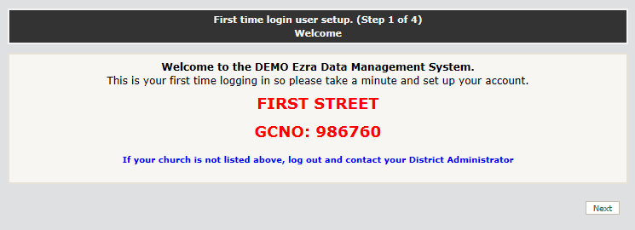

- Enter your name and contact information as requested. Click the Next button.
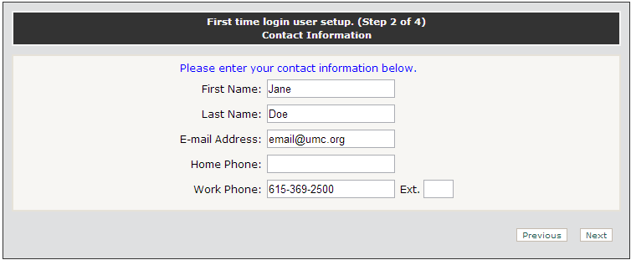

- Enter the current password and the new password that you would like to use. Confirm the password, then click Next.
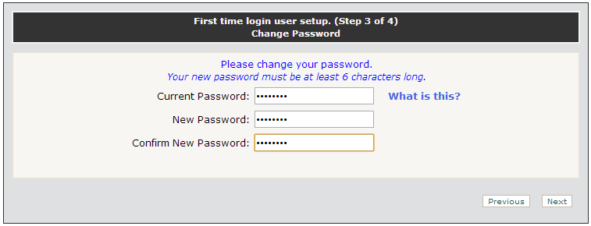
- Your log in setup is complete. Click the Finish button.
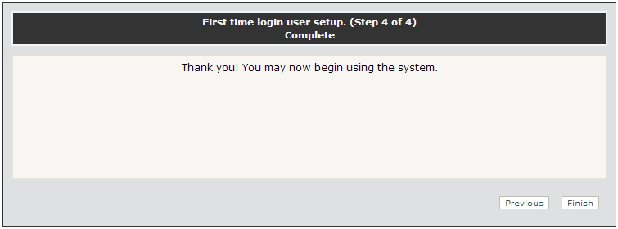

Welcome Panel
The Welcome Panel is the first thing you see after entering the Statistics module. The first thing you should do is print a blank report form to keep a hard copy of data entered in Ezra. This screen will show every time you log in until you have saved any changes to the tables.
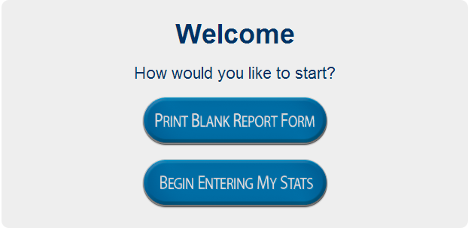
While reporting your statistics, the Welcome Panel will change to reflect your progress. You can click on the table names to go directly to the table.
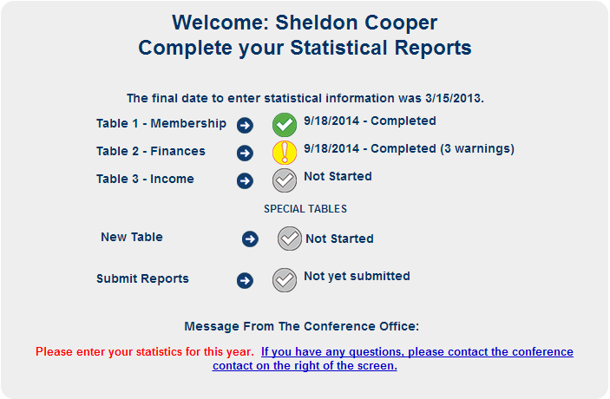

Side Menu Bar
The side menu bar provides access to frequently asked questions, a user guide, and a shortcut to the Blank Report Form and the Reports page. The Blank Report Forms are available on the menu bar on the right. Click on the Blank Report Forms button to open the subordinate buttons.
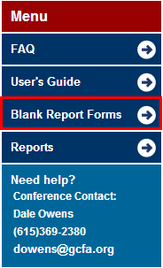

Reports

Reports Menu
Click the Report menu to activate the dropdown menu, then choose the desired report from the dropdown panel.
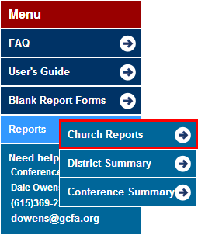

Individual Church Reports
Reports lists the type of reports that the module can automatically generate. Click on the hyperlink to download the desired report.
- To print the Individual Church Stats Report, click the hyperlink.
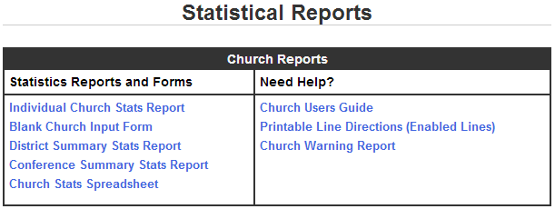

- When the Print Individual Church Input Forms page opens, select the desired church then click the Run Report button.
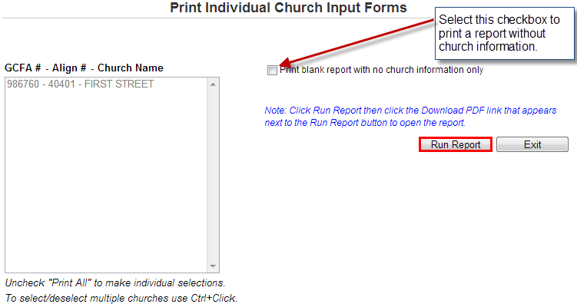
- Click the Download PDF hyperlink to download the generated report.
- When finished, click the Exit button to go to Statistical Reports.

Church Reports
This page allows the user to print the reported statistical numbers for churches.
- Print All checkbox is automatically selected. If an individual report is desired, deselect the checkbox and select the desired church from the panel.
- After selecting the desired church or churches, select the checkboxes next to the tables to print.
- Click the Run Report button to generate the reports.
- Select the type of report to download from the selection generated.
- When finished, click the Exit button.
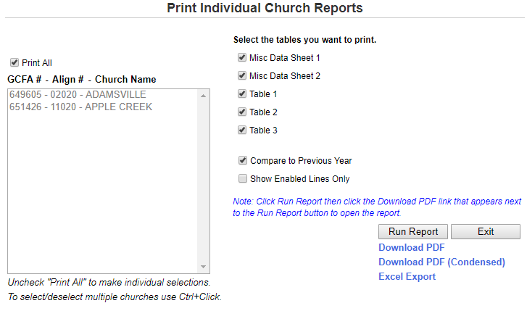

Charts
Charts creates graphs of the data submitted for a particular church or a range of churches. Click on the hyperlink and the graph will appear on a separate page.
- Click the desired information.
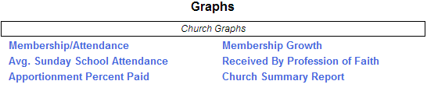
- The information will be generated, then displayed.
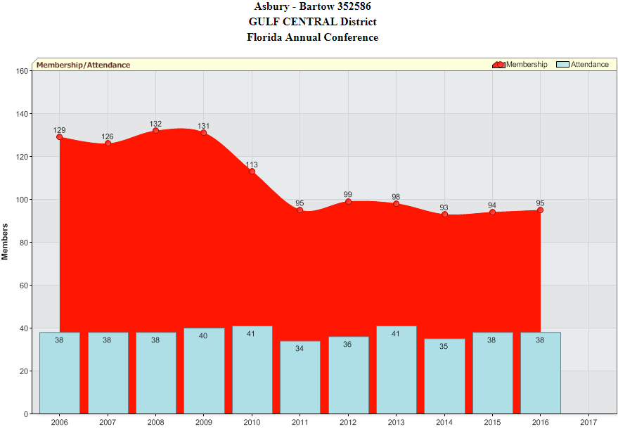

Enter Stats
After a Conference is selected, the dropdown box will display the selected conference and the number of churches in the database that belong to that conference. To further narrow the results, enter the name of the church in the Church Name search box or any other information in the related search boxes, then click the Search button.
- Select the year for the statistics that you are entering from the dropdown box.
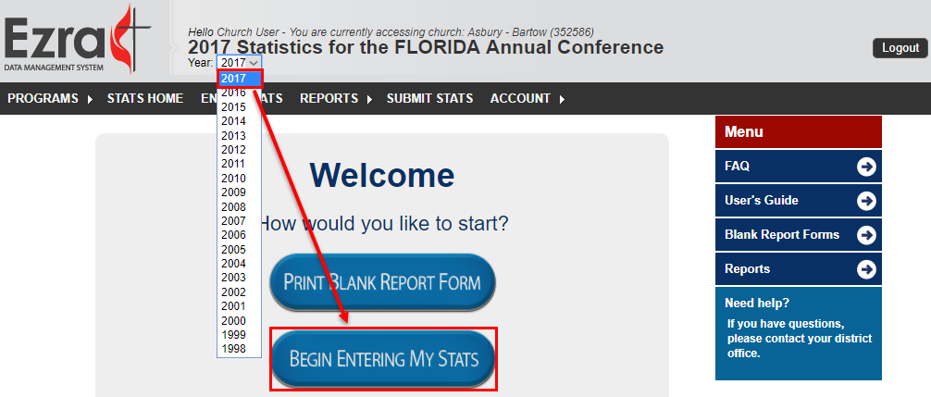
- Select the desired table to begin entering data.
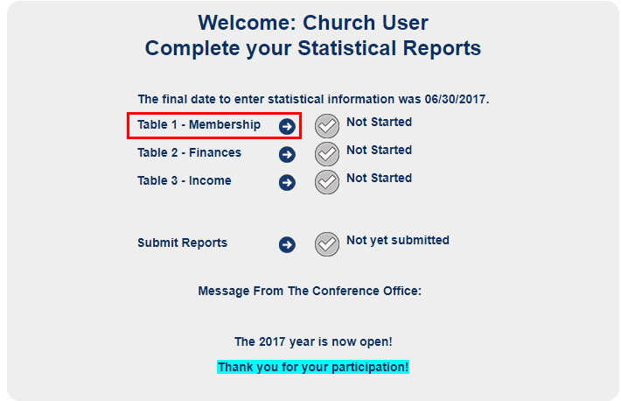
- Select the desired table from the dropdown box. Your alignment number and GCNO will automatically prepopulate.
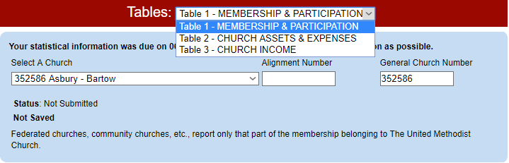
- Use the form that you filled out manually to populate the selected table. As you fill out the table the lines will reflect any errors or concerns.
Refer to the color guide for the color-coded issues.
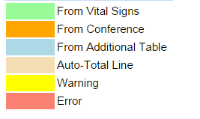

Make sure to save your work as you go.
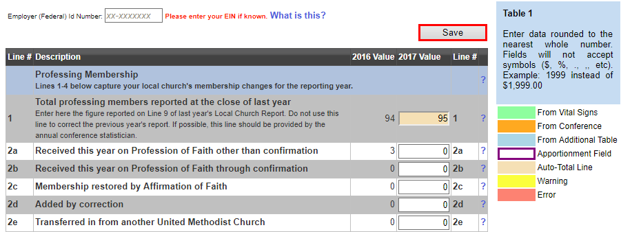
- On Table 1, Line 1 will be automatically filled in from last year’s Line 9 value.
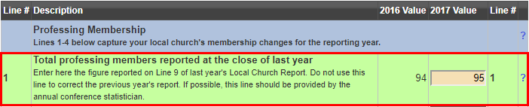
- Lines imported from the Conference or Auto-Total cannot be changed. Values from VitalSigns can be edited/overwritten.
- Once you are done entering in your values, click SAVE.
WARNINGS and ERRORS:
- Your conference has the option to have the system automatically check lines for increases/decreases or math errors.
  - If you report an item that triggers a warning, you have the option to edit the line (if it was incorrect) or enter in an explanation for the increase/decrease. Your conference will choose whether warnings must be corrected or explained in order to submit your report. If explanations are required, you will not be able to submit without entering an explanation.
  - All errors must be corrected -- tables cannot be submitted with errors.

Submit Stats
To submit your statistics to the conference, click Submit Stats link on the Main Menu. After the icons confirm the completion of the tables. Click Submit Statistics to send the tables to the conference.
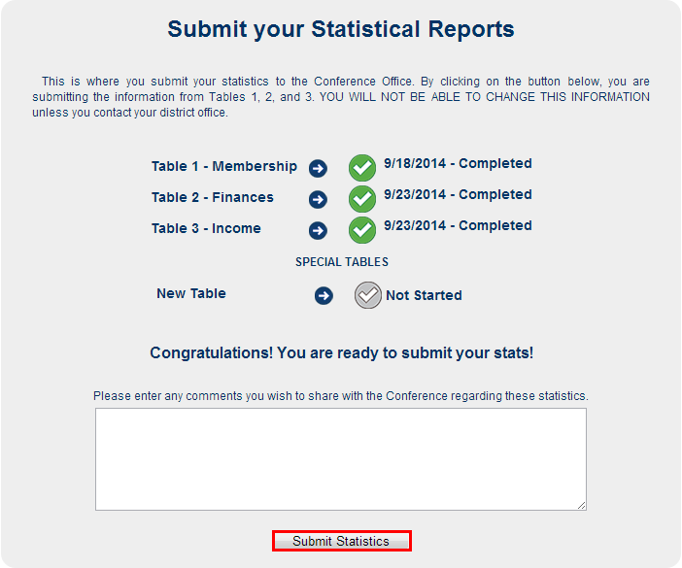
Click OK to confirm the submission.
