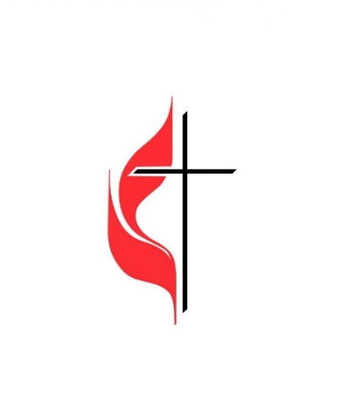
New Life United Methodist Church
2600 Bond Ave. Drexel Hill, PA 19026
Rev. Evelyn Kent Clark, Pastor

Health Fair:
Wellness Rocks

Hosted by the New Life’s Health and Wellness
Date: Saturday, April 21, 2018
Time: 10am-1pm
Location: New Life United Methodist Church
Activities will include:
Health screenings, Blood pressure, Nutrition, Hearing testing, Snap Outreach, Zumba, Dental screening, Keystone VIP Choice, Victim of crime & identity theft information, Pathways PA, Rite Aid, Walgreens Health Partners, IBX Chips, Mercy Health System, COSA, Vendors, Give a Ways, Main Line Health, Penn Medicine Volunteers, Mercy L.I.F.E., Fox Chase, Glucose screening, Penn Community Outreach, and much more…
Continental Breakfast /Gifts and Prizes
Chairperson: Barbara Phillips, 610-622-7318
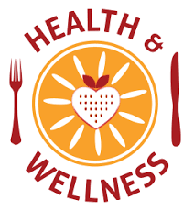
Co-chairperson: Pamela Henry, 610-623-0503

