http://friedensfolks.org/taufschein/

Taufschein (Baptismal Certificate)

in the Pennsylvania Dutch Fraktur folk art style

Created by Jonathan Bond
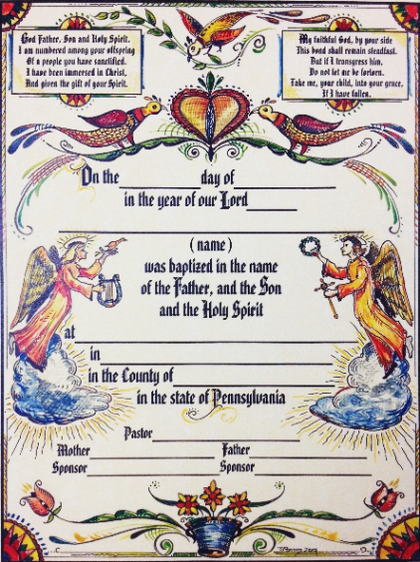
Commissioned by the East Berks Mission District (Northeastern Pennsylvania Synod, Evangelical Lutheran Church in America) in commemoration of the 500th anniversary year of the Reformation
Soli Deo Gloria © 2017
The Taufschein, or Baptismal Certificate, is one of the most widely proliferated examples of Fraktur, the manuscript art of the Pennsylvania Germans. Taufscheine were especially prominent among Lutheran and German Reformed congregations in our region, and Berks County was the epicenter of Taufschein production. As Lutherans in Berks County, we are re-printing Taufscheine in order to celebrate and bring to life our cultural and theological heritage.
Kempton artist Jonathan Bond reimagined these certificates, using traditional folk art symbols to convey religious insights and cultural values. Angels holding a crown and harp speak of the promise of eternal life. A branch emerging from a pot conveys the resurrection. Three flowers from one stem symbolize the Trinity. And last but not least, the Distelfink represents characteristics valued by the Pennsylvania Dutch: thrift, grit, and endurance. The poems are English translations of 19th century German hymns found on printed Taufscheine, rendered by Patrick Donmoyer of the Pennsylvania German Cultural Heritage Center at Kutztown University.
One need not be Pennsylvania Dutch, Lutheran, or German Reformed to value the beauty of this local tradition; so, we are offering these certificates to the public in the hope that they will be used in a variety of ecclesial settings in modern day Berks County and beyond. As we commemorate the 500th anniversary of the Reformation, we pray that future generations will treasure their baptismal identity.
Certificates are matted for a 12″ x 16″ frame. They are $7.50 each. Unmatted certificates are $3.00 each. We are selling to cover our costs, but any proceeds will fund our ministry as a Mission District, including social ministry projects like The Potato Project, joint youth ministry, and leadership training and development.

Order here: Taufschein order form
Note: If you are a congregation of the East Berks Mission District, please do not send a check before contacting Pastor Inge Williams at pastor.inge.williams@gmail.com, 610-488-7325

